LED 96+32 RGBW STROBE

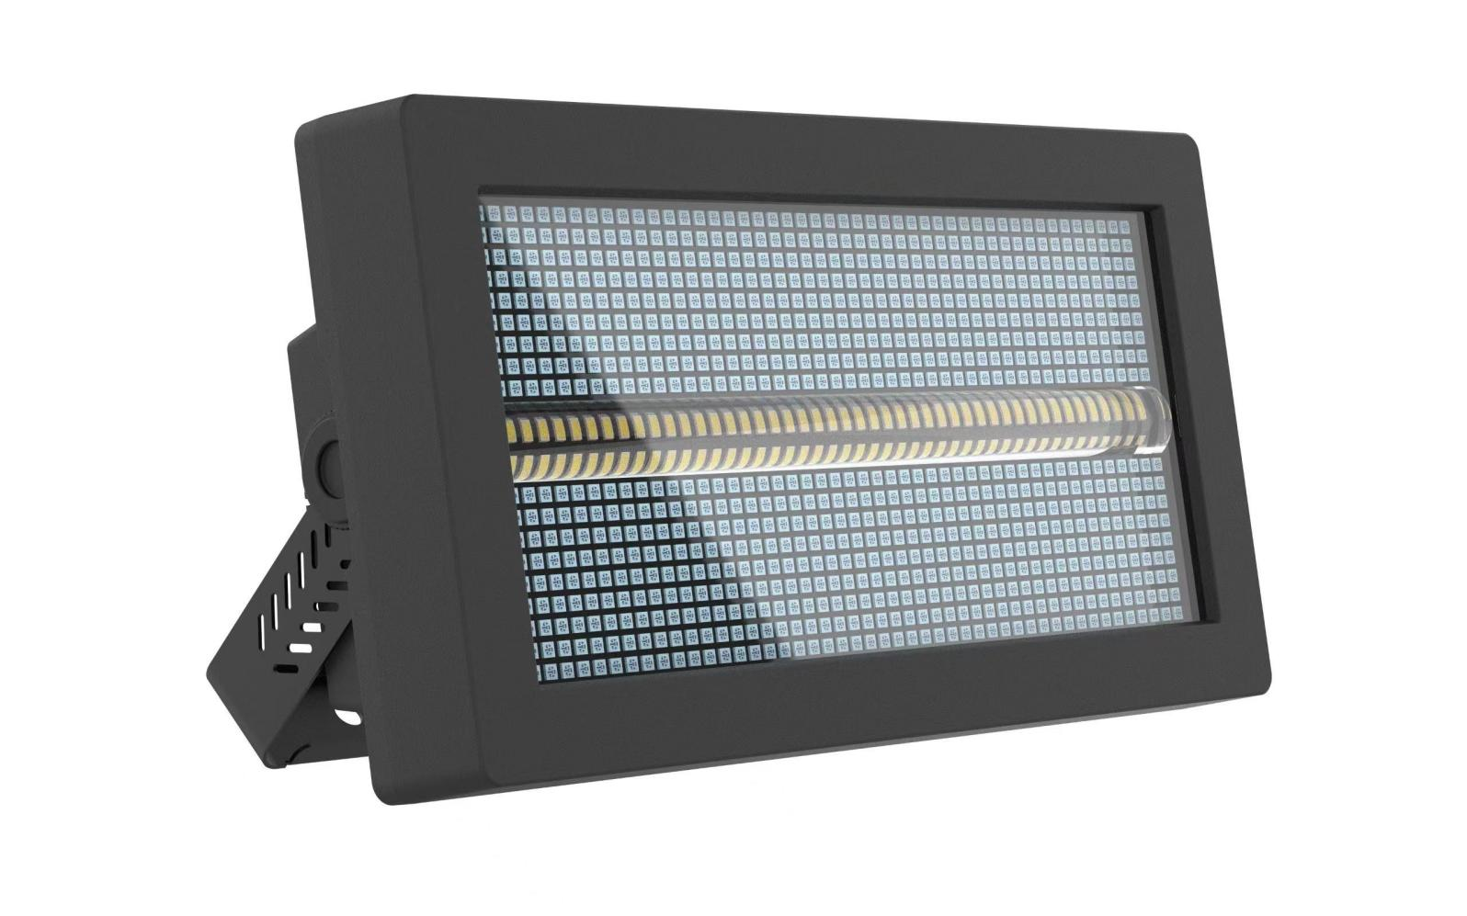

Instruction Manual

Definition of display panel and buttons
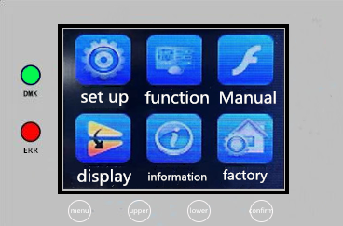

Menu keys：Enter/Return to Main Menu
Up Key: Menu function up selection/parameter increment
Down key: Menu function down selection/parameter decrement
Confirm key：Select the menu function and make a confirmation and save when modifying the menu function parameters.

Menu functions
Main menu | Submenu | Menu Function Description
System settings | DMA address | Modify the DMA address code up or down (with an optional range of 001-512), confirm to save, and default to 001.
System settings | Advanced Settings | Modify the encoder on/off up or down, save with the confirm button, and default to on.
Operating mode | Operating mode | Select the operation mode up or down, such as DMA/voice control/automatic, and press the confirm button to save. The default mode is DMA.
Operating mode | Channel selection | Select channels CH4/CH17/CH121/CH145 up or down to save, default to CH17.
Manual | Dimming | Modify the dimming parameter values up or down (adjustable range 000-255), confirm to save, default to 255.
Manual | RGBW strobe | Modify the strobe parameter value up or down (adjustable range 000-255), confirm to save, default to 000.
Manual | Red | Modify the red parameter value up or down (adjustable range 000-255), confirm to save, default to 000.
Manual | Green | Modify the green parameter value up or down (adjustable range 000-255), confirm to save, default to 000.
Manual | Blue | Modify the blue parameter value up or down (adjustable range 000-255), confirm to save, default to 000.
Manual | White | Modify the white parameter value up or down (adjustable range 000-255), confirm to save, default to 000.
Manual | RGB mode | Modify the mode parameter values up or down (adjustable range 000-255), confirm to save, default to 000.
Manual | RGB speed | Modify the speed parameter value up or down (adjustable range 000-255), confirm to save, default to 000.
Manual | Seven Colors | Modify the seven color parameter values up or down (adjustable range 000-255), confirm to save, default to 000.
Manual | W mode | Modify the W mode parameter values up or down (adjustable range 000-255), confirm to save, default to 000
Manual | W speed | Modify the W speed parameter value up or down (adjustable range 000-255), confirm to save, default to 000
Manual | RGBW mode | Modify the parameter values up or down (adjustable range 000-255), confirm to save, default to 000.
Manual | RGBW speed | Modify the parameter values up or down (adjustable range 000-255), confirm to save, default to 000.
Manual | Background color | Modify the parameter values up or down (adjustable range 000-255), confirm to save, default to 000.
Manual | Background tone light | Modify the parameter values up or down (adjustable range 000-255), confirm to save, default to 000.
Manual | Character | Modify the character parameter values up or down (adjustable range 000-255), confirm to save, default to 000.
Manual | Direction | Modify the direction parameter value up or down (adjustable range 000-255), confirm to save, default to 000.
Display Settings | Language selection | Select Chinese/EN (English) up or down, confirm to save, default to Chinese.
Display Settings | Invert Settings | Select up or down to turn off/on the inverted display setting, confirm to save, default to off.
Display Settings | Screen saver | Select up or down to turn off/on screen saver, confirm to save, default to on.
Display Settings | Software version | G37A program identification code, cannot be modified.
Factory  settings | Please enter password for display! Change up or down to 138, then press the confirm button to enter the factory settings。 | Red | Modify the red light bead current (032-255) up or down, confirm to save, default to 255.
Factory  settings |  | Green | Modify the green light bead current (032-255) up or down, confirm to save, default to 255.
Factory  settings |  | Blue | Modify the blue light bead current (032-255) up or down, confirm to save, default to 255.
Factory  settings |  | White | Modify the red light bead current (032-255) up or down, confirm to save, default to 255.
Factory  settings |  | Logo | Modify the green bead current (032-255) up or down, confirm to save, default to 255
Factory  settings |  | Temperature | Modify the blue light bead current (032-255) up or down, confirm to save, default to 255
Factory  settings |  | Temperature - Fan | Modify the white light bead current (032-255) up or down, confirm to save, default to 255

CHANNEL
CH4：
Thoroughfare | Channel value | Basic function
1 | 000-255 | The red light bead dims linearly.
2 | 000-255 | Green bead linear dimming.
3 | 000-255 | Blue bead dimming linearly.
4 | 000-255 | White light beads linearly dimming.

CH17
Thoroughfare | Channel value | Basic function
1 | 000-255 | Total dimming
2 | 000-255 | RGBW strobe
3 | 000-255 | The red light bead dims linearly.
4 | 000-255 | Green bead linear dimming.
5 | 000-255 | Blue bead dimming linearly.
6 | 000-255 | White light beads linearly dimming.
7 | 000-255 | Colorful (walking through the mode will have a colorful effect)
8 | 000-255 | RGB effect mode selection
9 | 000-255 | RGB effect mode speed
10 | 000-255 | W Effect Mode Selection
11 | 000-255 | W effect speed
12 | 000-255 | RGBW effect mode selection
13 | 000-255 | RGBW effect speed
14 | 000-255 | Background color
15 | 000-255 | Background tone light
16 | 000-255 | Static pattern (numbers/letters)
17 | 000-255 | Static pattern direction.

CH145
Thoroughfare | Channel value | Basic function
1 | 000-255 | Total dimming
2 | 000-255 | RGBW strobe
3 | 000-255 | The red light bead dims linearly.
4 | 000-255 | Green bead linear dimming.
5 | 000-255 | Blue bead dimming linearly.
6 | 000-255 | White light beads linearly dimming.
7 | 000-255 | RGB effect mode selection
8 | 000-255 | RGB effect mode speed
9 | 000-255 | Colorful (walking through the mode will have a colorful effect)
10 | 000-255 | W Effect Mode Selection
11 | 000-255 | W effect speed
12 | 000-255 | RGBW effect mode selection
13 | 000-255 | RGBW effect speed
14 | 000-255 | Background color
15 | 000-255 | Background tone light
16 | 000-255 | Static pattern (numbers/letters)
17 | 000-255 | Static pattern direction.
18 | 000-255 | W1
19 | 000-255 | W2
20 | 000-255 | W3
21 | 000-255 | W4
22 | 000-255 | W5
… | … … | … …
47 | 000-255 | W32
48 | 000-255 | RGB1
49 | 000-255 | RGB2
50 | 000-255 | RGB3
… | … … | … …
145 | 000-255 | RGB96

Technical parameters:
Voltage: AC100~240V 50/60HZ
Power: 350W (RGB: 130W, W: 220W)
Lamp beads: 256 3030 white light 1 watt, 864 5050 RGB 0.2 watt lamp beads
Control mode: DMX512, self-propelled, master-slave, voice control, with RDM function.
Channels: CH04, CH17, CH145
Dimming: 0-100% linear dimming
Features: 96 segments RGB+32 segments W+dyeing+flashing
Working temperature: -30 °C~60 °C
Strobe frequency: 1-30Hz
Appearance: Metal, black
Connection method: DMX512 input/output/power input/output.
IP level: IP20

